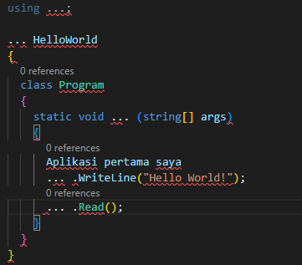

1. using System;
2. namespace HelloWorld;
3. static void Main (string[] args)
4. Console.WriteLine(“Aplikasi pertama saya”);
5. Console.WriteLine(“Hello World!”);
6. Console.Read();